Project Proposal
Project Title
- CentricAI: AI-Powered Personal Finance Advisor
Project Overview
- Objective: The primary goal of this project is to develop an AI-driven personal financial advisor that empowers individuals with informed money management decisions. This system will analyze mock financial data, including income, expenses, and savings, to provide personalized recommendations on budgeting, spending, and saving strategies. A key focus will be on explainability, ensuring every recommendation is accompanied by transparent and easy-to-understand reasoning.
To make the success criteria measurable, a key milestone for the semester will be to demonstrate a functioning prototype to the advisor. This prototype will analyze mock financial data, provide clustering-based insights into spending habits, and include at least one explainable recommendation module, such as a budgeting suggestion with clear, transparent reasoning. This concrete deliverable ensures the project stays on track and shows tangible progress toward the final objective.
- Scope:
  - In Scope: Use of mock or synthetic financial datasets simulating transactions, expenses, and income flows
  - Development of a dashboard or conversational interface where users can view recommendations
  - Integration of AI/ML techniques to cluster spending behavior, predict savings potential, and provide rule-based + AI-driven financial advice
  - Focus on explainability to ensure users understand why recommendations are made
  - Deployment as a demo application (web-based or cloud-hosted service)
  - Basic monitoring capabilities for tracking recommendation accuracy, data drift, and system reliability
  - Out of Scope / Limitations: No connection to real banking APIs (e.g., Plaid, Yodlee) for live account linking
  - Recommendations will be non-regulatory and non-certified (not official financial advice)
  - Data will be mock or anonymized for privacy and compliance
  - The project will not include advanced financial instruments (e.g., stock trading, investment portfolio optimization).
  - Data Source and Structure: To ensure the project's feasibility, the system will be trained and evaluated using a synthetically generated financial dataset. This approach allows for full control over the data's characteristics, including user profiles, income streams, and expense patterns. We'll generate data that simulates diverse financial behaviors, ensuring the AI advisor is robust enough to handle various scenarios. The dataset's structure will include key attributes for each transaction, such as:
    - Transaction ID: A unique identifier for each entry
    - Date: The date the transaction occurred
    - Amount: The monetary value of the transaction
    - Type: The transaction category (e.g., income, expense)
    - Category: A specific sub-category for expenses (e.g., groceries, rent, entertainment)
    - Description: A brief text description of the transaction
    - This synthetic dataset will be sufficiently large to allow for meaningful analysis and the development of effective clustering and recommendation modules, while avoiding privacy concerns associated with real financial data.
- AI Techniques and Tools:
  - AI Methods & Algorithms
    - Unsupervised Learning (Clustering): To group similar spending patterns
    - Supervised Learning / Forecasting: To predict savings potential based on income/expense trends
    - Rule-Based Systems + LLM Integration: To generate financial advice in natural language and provide explainable recommendations
  - Tools & Frameworks
    - Python for data preprocessing, modeling, and backend logic
    - Pandas, NumPy for data handling
    - scikit-learn / XGBoost for clustering and predictive modeling
    - Prophet or ARIMA for time series forecasting (optional, for savings projection)
    - LangChain / OpenAI API (or similar LLM framework) for natural language financial explanations
    - Flask or FastAPI for backend service
    - Streamlit / Dash / React (if front-end heavy) for user-facing dashboard
    - Docker + Cloud Deployment (AWS/GCP/Azure or Render/Heroku) for deployment
    - Prometheus + Grafana (or lightweight logging) for system monitoring
    - The technical plan will focus on developing an AI-driven personal financial advisor through a phased implementation to manage the project's ambitious scope.
    - Phase 1: Core Functionality (Mandatory Deliverable)
      - Data Preprocessing and Feature Engineering: Clean and transform the synthetic financial data
      - Clustering: Apply machine learning algorithms (e.g., K-Means) to identify and categorize spending patterns
      - Basic Forecasting: Implement a simple time-series model (e.g., ARIMA) to predict future spending trends based on historical data
      - Recommendation Engine: Develop a rule-based or collaborative filtering engine to provide initial budgeting and saving recommendations
      - Phase 2: Advanced Features (Stretch Goal) LLM Integration for Explainability: Integrate a large language model (LLM) using a framework like LangChain to provide sophisticated, natural language explanations for the recommendations. This includes generating summaries of spending habits and providing reasoning behind budgeting suggestions
      - My confidence level in successfully integrating LangChain/LLMs is a 6 out of 10. Given that this is a relatively new and complex area, I am treating the full implementation of LLM explanations as a stretch goal. My priority is to first ensure that the core data analysis and basic recommendation features of the project are fully functional and robust. This strategic approach mitigates the risk associated with complex LLM integration, ensuring that a valuable and complete project can still be delivered even if the advanced features are not fully realized.
Project Timeline
- Milestones:
  - Week 1–2: Project planning, dataset design (mock financial data), tool setup
  - Week 3–5: Data preprocessing, exploratory analysis, baseline models
  - Week 6–8: Develop clustering + forecasting models, integrate rule-based logic
  - Week 9–10: Build prototype dashboard / conversational interface
  - Week 11–12: Deploy system to cloud, implement monitoring (logs, metrics)
  - Week 13: Testing, refinement, documentation
  - Week 14: Final presentation & submission
- Timeline:
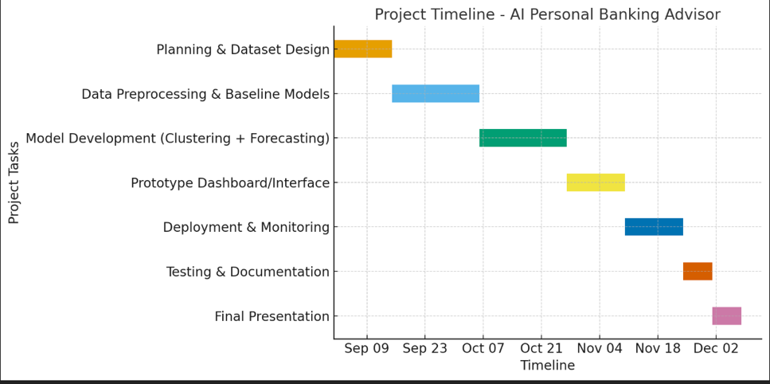
Budget and Resources
- Budget Overview:
  - Personnel: No additional cost (student-led)
  - Data: Mock datasets (no cost)
  - Tools: Open-source libraries (scikit-learn, pandas, Streamlit, etc.)
  - Cloud/Deployment: Minimal cost (~$20–30) for hosting (AWS/GCP/Heroku/Render)
- Resource Allocation:
  - Early Phase (Weeks 1–5): Time focused on data + modeling
  - Mid Phase (Weeks 6–10): Majority effort on model refinement + system integration
  - Late Phase (Weeks 11–14): Resources toward deployment, monitoring, and presentation polish.
Stakeholders
This project has several key stakeholders who will benefit from its successful completion and will provide valuable insights throughout the development process.
- Project Team:
  - Project Lead (Student): Responsible for overall design, development, and management of the AI financial advisor system
  - Technical Support (Professor / TA): Provides guidance on AI techniques, system design, and project milestones
  - Peer Reviewers (Classmates): Offer feedback on system usability, testing, and evaluation
- End Users: Individual Consumers (users) who want to manage personal finances. They will interact with the system through a dashboard or conversational interface, receiving personalized recommendations and explanations.
- Other Stakeholders:
  - Data Providers: Mock or synthetic financial datasets used for training/testing
  - Regulatory Considerations: While not binding for this project, financial advising systems must consider compliance with financial regulations and ethical AI practices
  - Future Partners (Optional): Fintech companies or banking APIs (e.g., Plaid) that could be integrated in later iterations beyond the class scope
  - Primary Users (Individuals): The direct beneficiaries of the project. They will use the AI-driven financial advisor to manage their personal finances, track spending, and receive personalized advice. Their feedback on usability and the clarity of recommendations is crucial
  - Project Advisor: Provides academic guidance, technical expertise, and helps ensure the project meets its defined objectives and milestones
  - Financial Literacy Organizations and Consumer Advocacy Groups: These groups represent a vital stakeholder base. Their insights will be sought to validate the tool's usability, ethical considerations, and its effectiveness in promoting responsible financial behavior. Their involvement ensures the tool is not only technically sound but also aligns with principles of fairness and transparency, building trust with a broader user base
  - Potential Investors or Partner Institutions: Entities interested in the commercial application of the tool. Their interest will focus on the system's scalability, effectiveness, and market viability

